- Admin 4 – Fleet Admin Dashbord
This module contains and manages all the global master-level data required for the PMS system.
It includes four key master tables, which help standardize information across all vessels and ensure consistent data mapping.

- Maker List
- Master Data
- Fleet Equipment Data
- Master List
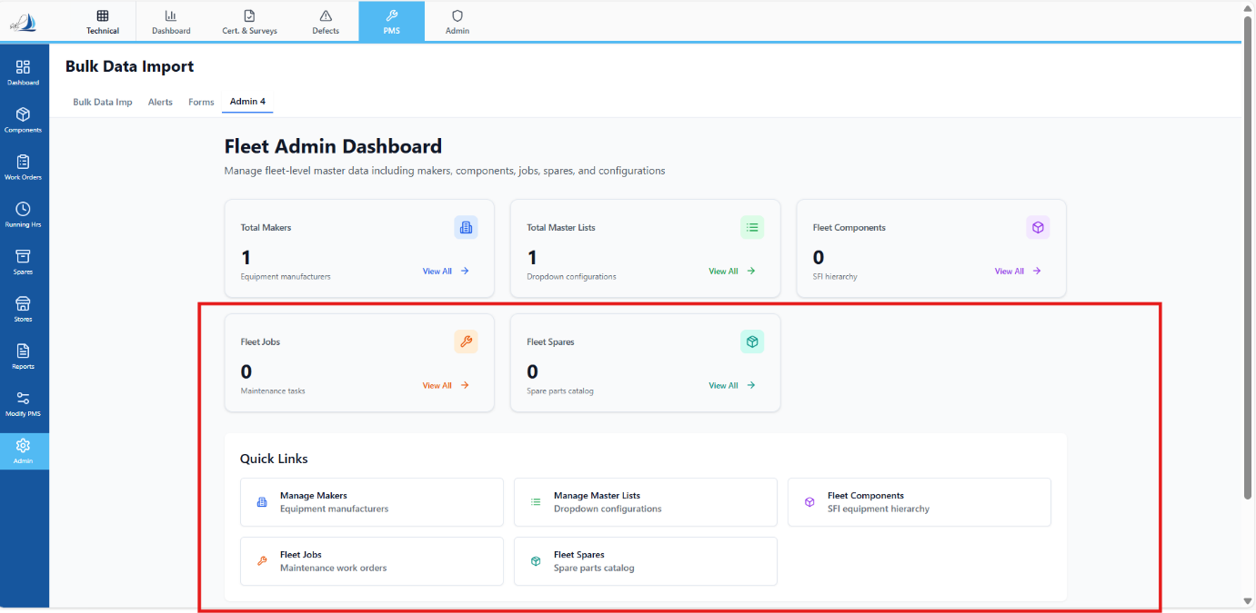
In Below SS the Red Highlighted data is not required. Above mentioned fields only need to be created.

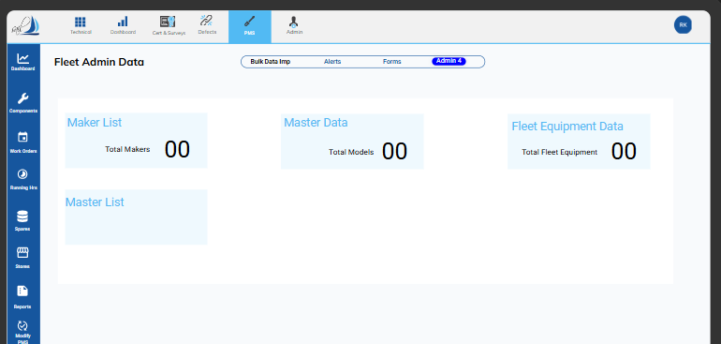
For Ref we can go through this.

0
- Maker List:
Linked with the Master Data and Fleet Equipment Data.
When we click on the Maker List in the Fleet Admin Dashboard, the following interface should open:
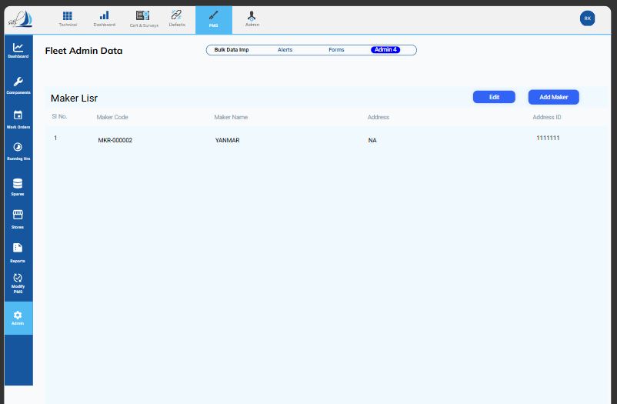

Editing a Maker
To edit a maker, select the maker you want to modify and then click the Edit button located at the top right.
When clicked, the Edit Maker interface will open.
Update the necessary details and click Save Changes.
Adding a New Maker
To add a new maker, click the Add Maker button.
The Add New Maker interface will open.
Enter the required fields and click Create Maker to save.
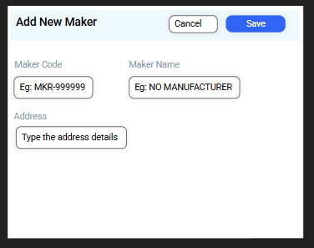
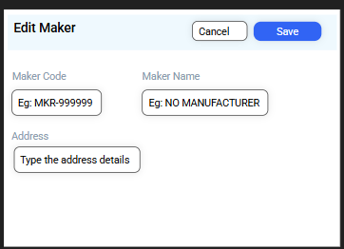

- Master Data.
Linked with the fleet Equipment data.
When we click on the Master data in the Fleet Admin Dashboard, the following interface should open:
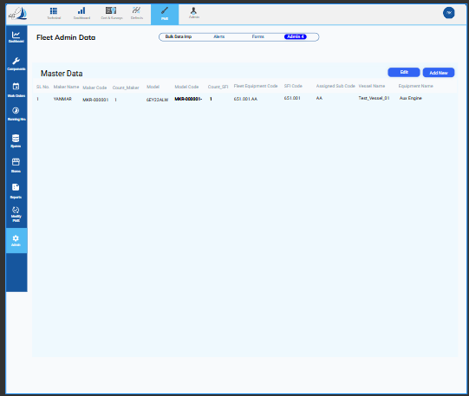

Editing Master Data
To edit a maker, select the maker you want to modify and then click the Edit button located at the top right.
When clicked, the Edit Master Data interface will open.
Update the necessary details and click Save Changes.
Adding a New Master Data
To add a new Master data, click the Add New button.
The Add Master Data interface will open.
Enter the required fields and click Create New to save.
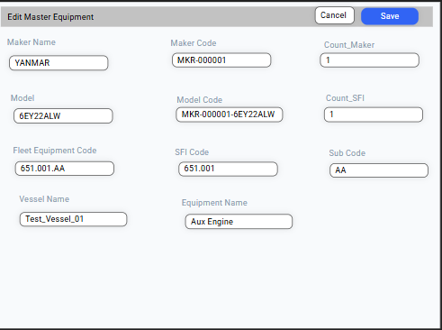
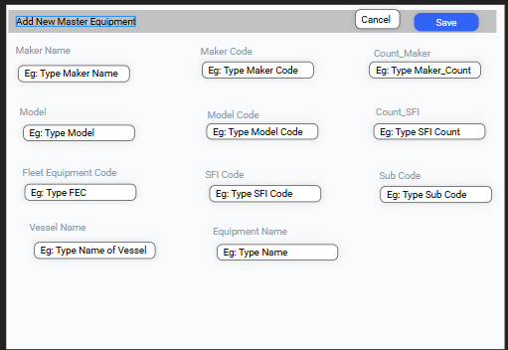

- Fleet Equipment Data.
All the vessel data will be distributed from this module.
When we click on the Fleet Equipment Data in the Fleet Admin Dashboard, the following interface should open:
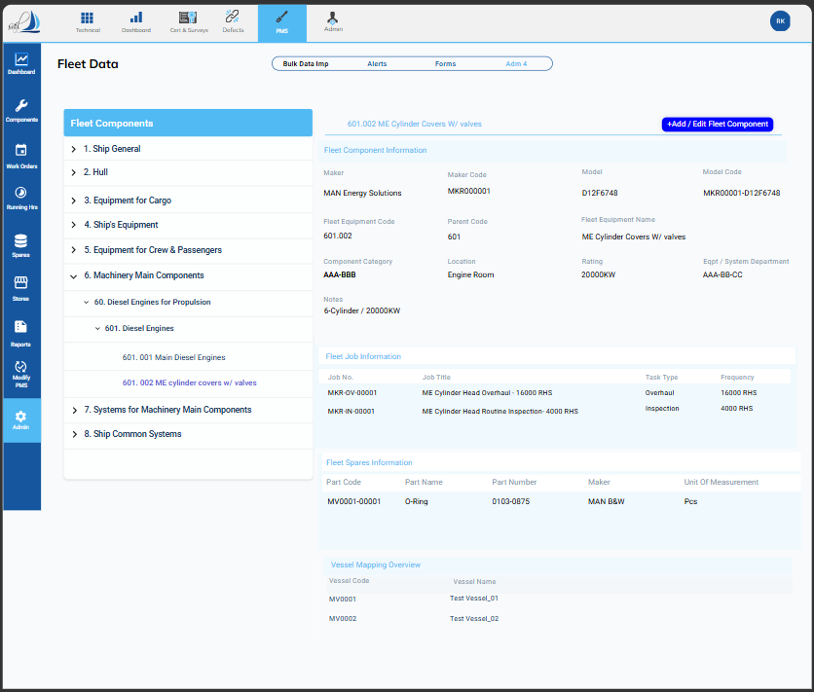

+ Add / Edit Fleet Component
Click on the + Add / Edit Fleet Component button. The interface shown below will then open.
To Edit:
Select the equipment that needs to be edited, make the required changes, and click Save.
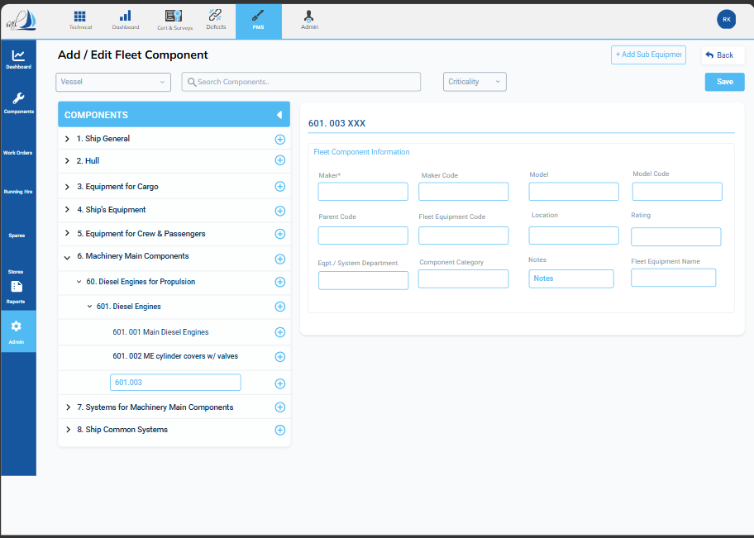
To Add a New Component:
Select the parent code under which the new equipment should be created.
Enter the required fields and click Save.

3a. Fleet Job Information:
When we click on the Fleet job information on the Fleet Equipment data Interface the below mentioned interface should be opened.
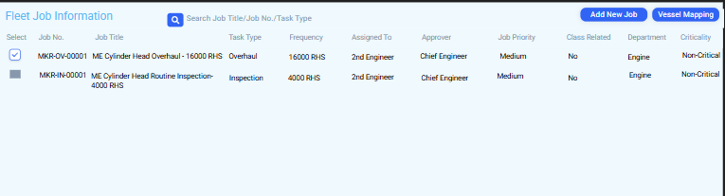

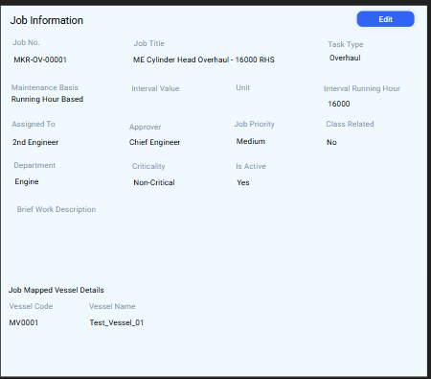
For more details, click on the job. The Job Information interface will then open, as shown in the screenshot below..

To edit the job information, click the Edit button. The interface shown below will open. Update or rewrite the required fields and click Save.
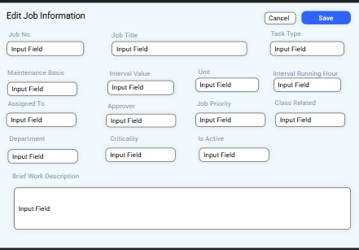

To add a new job, click the Add New Job button. The interface shown below will open. Fill in the required fields and click Save.
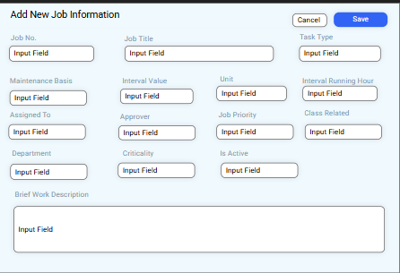

To map the fleet job to the vessel side, select the job that needs to be distributed. Then click on the Vessel Mapping button. The interface shown below will open.
A list of vessels linked to that particular equipment code will appear. Select the vessel to which you want to distribute the job and click Map.
To remove the mapping, select the vessel name and click Remove Map.
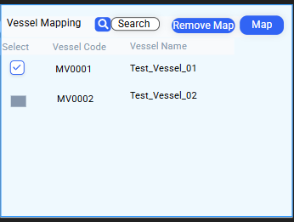

3.b Fleet Spare Information
When we click on the Fleet Spare information on the Fleet Equipment data Interface the below mentioned interface should be opened.
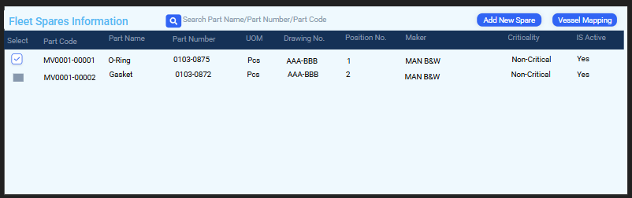

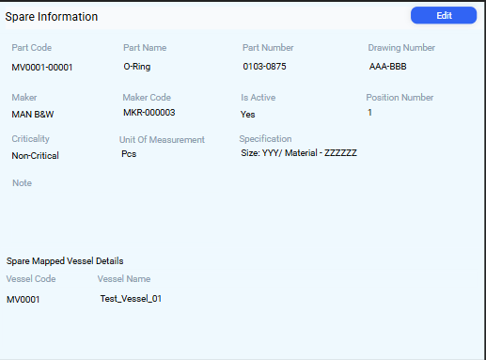
For more details, click on the Spare. The Spare Information interface will then open, as shown in the screenshot below.

To edit the Spare information, click the Edit button. The interface shown below will open. Update or rewrite the required fields and click Save.
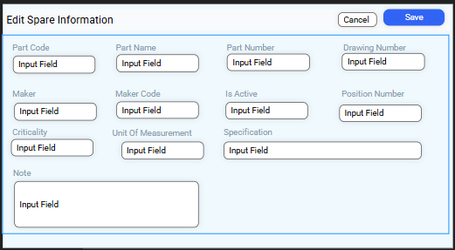

To add a new Spare, click the Add New Spare button. The interface shown below will open. Fill in the required fields and click Save.
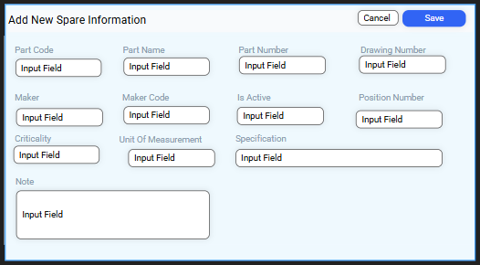

To map the fleet Spare to the vessel side, select the Spare that needs to be distributed. Then click on the Vessel Mapping button. The interface shown below will open.
A list of vessels linked to that particular equipment code will appear. Select the vessel to which you want to distribute the Spare and click Map.
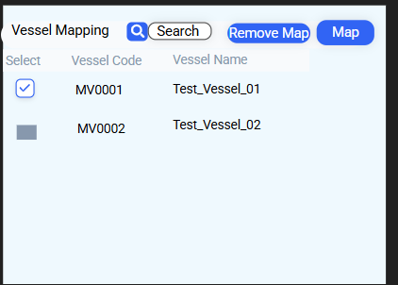
To remove the mapping, select the vessel name and click Remove Map.

3.C Vessel Mapping Overview
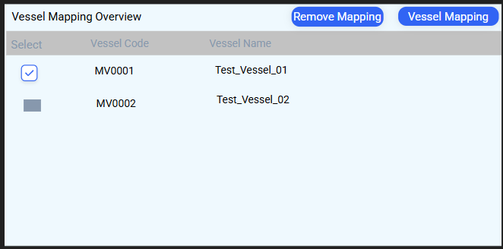
When we click on the Vessel Mapping Overview in the Fleet Equipment Data interface, the interface shown below should open. This screen will display the list of vessels that are linked to the selected Fleet Equipment code.

To link the Fleet Equipment code with another vessel, click on Vessel Mapping from the Vessel Mapping Overview. The interface shown below will open. Search and select the vessel code, then click Map.
To remove an existing mapping, select the vessel you want to unmap and click Remove Mapping in the Vessel Overview interface.

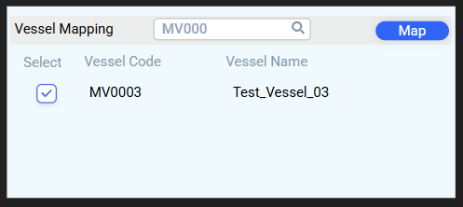

Vessel Component Mapping overview.
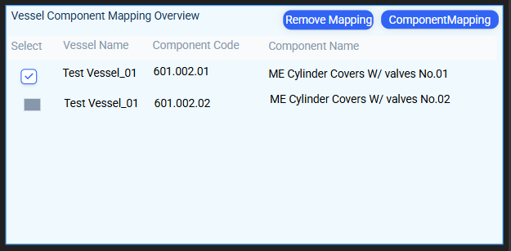
Click on the vessel name or vessel code in the Vessel Mapping Overview screen.
A new interface (Vessel Component Mapping Overview) will open, displaying the details of that vessel’s components linked to the selected Fleet Equipment code, as shown in the screenshot below.

To remove a component mapping, select the component and click Remove Mapping.
To map a new component, click Component Mapping. A new interface will open. Search for the component name or code, select the component, and click Map.
